Neural Network Training and Overfitting Control with Early Stopping

Metadata
Created at: 2026-03-29 10:19:00
Video ID: Ygvskt5HadI

Notes

Neural Network Training and Overfitting Control with Early Stopping

Need to Improve Neural Network Training
- Goal: Train a neural network so that it generalizes well to new, unseen data.
- Core issue: Deciding how long to train (number of epochs / passes over the data).
- Too few epochs:
- Model underfits; has not fully learned useful patterns.
- Too many epochs:
- Model overfits; memorizes training examples and loses generalization ability.

Epochs in Neural Network Training
- In training, you specify how many times the model should see the same training examples:
- This is the **number of epochs**.
- Each epoch:
- One full pass over the entire training dataset.
- More epochs:
- More parameter updates on the same data.
- Initially helpful, but beyond a point can become harmful (overfitting).

Overfitting
- **Overfitting**:
- Model performs very well on training data.
- Model performs poorly on new/test/validation data.
- Behavior when overfitting:
- Training loss keeps decreasing, training accuracy keeps increasing.
- Validation/test loss begins to increase, validation/test accuracy stagnates or decreases.
- Cause:
- Model starts memorizing training examples instead of learning generalizable patterns.
- Degree depends on dataset complexity and model capacity.

Objective and Experimental Setup
- Aim: Demonstrate overfitting and show how to stop training early using validation performance.
- Procedure:
- Create a synthetic 2D classification dataset.
- Build and train a simple feedforward neural network.
- Monitor training and validation behavior over many epochs.
- Use this behavior to motivate and demonstrate early stopping.

Data Preparation
- Dataset:
- Generated with `make_circles` (scikit-learn) to create a 2D binary classification dataset.
- Number of data points: on the order of a few thousand (approx. 3000–5000).
- Data split:
- Split into training and test (or validation) sets.
- Test/validation set passed to `model.fit(...)` via `validation_data` (or similar) to monitor validation loss/accuracy each epoch.

Model Architecture
- Framework: Keras.
- Model type: Simple feedforward neural network for binary classification.
- Layers:
- Input layer: 2D features from `make_circles`.
- One hidden layer:
- Dense (fully connected).
- 256 neurons.
- Output layer:
- Produces classification output (binary decision for inner vs outer circle).
- Design choice:
- Architecture intentionally simple to clearly illustrate overfitting and early stopping behavior.

Model Compilation
- To compile the model, three components are specified:
1. **Loss function**:
- Appropriate for binary classification (e.g., binary cross-entropy).
2. **Optimizer**:
- E.g., SGD, Adam (exact choice not emphasized).
3. **Metrics**:
- E.g., accuracy, to track performance during training.
- These are passed in `model.compile(...)`.

Initial Training Configuration (Without Early Stopping)
- Training:
- Model trained for a large number of epochs (around 3500).
- Purpose: deliberately allow the model to overfit so the effect is visible.
- Validation:
- Validation data provided to track validation loss/accuracy over epochs.
- Output control:
- `verbose` parameter used (e.g., `verbose=0` or `2`) to reduce console logs.
- Observed result:
- Final classifier is “okay”:
- Many points correctly classified; some misclassified.
- Decision boundary roughly acceptable.
- However, training likely **over-shot** the optimal point due to very long training.

Training vs. Validation/Test Loss Behavior
- During training, both training loss and validation/test loss are monitored over epochs.
- Typical graph:
- Blue curve: training loss.
- Orange curve: validation/test loss.
- At the beginning:
- Both training and validation losses decrease as epochs increase.
- Indicates that the model is learning useful patterns and improving generalization.

Onset and Diagnosis of Overfitting
- After some epoch:
- Training loss continues to decrease.
- Validation/test loss begins to increase or flatten.
- Interpretation:
- Model is fitting training data more tightly.
- Generalization to unseen data is worsening.
- This divergence (validation loss going up while training loss goes down) signals overfitting / overshooting.
- Visual diagnostic:
- The epoch where validation loss is minimal is approximately the point where generalization is best.
- Example observation:
- Up to around $\sim 300$ epochs, validation loss decreases.
- After $\sim 300$–$350$ epochs, validation loss increases while training loss still decreases.

Choosing the Right Number of Epochs
- Based on loss curves:
- The “best” number of epochs is near the epoch where validation loss reaches its minimum.
- Practical conclusion:
- Optimal training duration is to stop at (or close to) the epoch of minimum validation loss.
- Training significantly beyond that point:
- Increases validation loss.
- Degrades validation accuracy.
- Leads to overfitting.

Motivation for Early Stopping
- Problem:
- Manually picking a fixed large epoch count (e.g., 3500) risks overfitting.
- Manually inspecting curves after the fact is inefficient and not automated.
- Need:
- A mechanism to **automatically stop training at the right time**:
- When further training ceases to improve validation performance.
- Before overfitting becomes severe.
- Goals of early stopping:
- Prevent over-training on the training data.
- Maintain good performance on unseen data.
- Save computation time by avoiding unnecessary epochs.
- Avoid “over-shooting” the optimal parameter region.

Concept of Early Stopping
- Early stopping is a **regularization technique** used during model training.
- Instead of pre-deciding a very large number of epochs, training is monitored and automatically stopped at an appropriate point.
- High-level process:
- After each epoch:
- Evaluate performance (typically on validation data).
- Compare the current value of a chosen metric with the best value so far.
- If performance does not improve, or consistently worsens, stop training.
- Used to:
- Decide how long to train without manual intervention.
- Automatically determine the “right” stopping point for training.
- Avoid unnecessary extra training once performance stops improving.
- Benefits:
- Prevents overfitting by stopping near the best validation performance.
- Saves computation time.
- Automatically implements what manual curve inspection suggests.

Keras Callbacks and Early Stopping
- Keras **callbacks**:
- Objects that run custom code at certain points during training:
- At the end of each batch.
- At the end of each epoch.
- At the start/end of training, etc.
- Early stopping in Keras:
- Implemented as a specific callback type (e.g., `EarlyStopping`).
- After every epoch, this callback:
- Checks whether training is still yielding benefit according to a monitored metric.
- If not, it signals Keras to stop training.
- Other callbacks exist, but focus here is on the EarlyStopping-type callback.

Applying Early Stopping to the Model
- Model and compilation:
- Model architecture is re-instantiated but kept identical to the earlier model.
- Same layers, same number of units, same configuration.
- Compiled again with the same loss, optimizer, and metrics.
- No architectural or compilation changes are needed to use early stopping.

Early Stopping Callback Setup
- Implementation steps:
- Import or access the EarlyStopping-like callback class.
- Construct an instance, e.g.:
- Configure which metric to monitor (e.g., validation loss).
- Configure additional parameters (e.g., patience, mode, `min_delta`, `baseline`, `restore_best_weights`).
- Store the callback instance in a variable (e.g., `early_stopping`).

Choosing the Monitored Quantity
- A specific scalar metric is chosen to monitor during training (e.g., validation loss, validation accuracy, domain KPI).
- Used to decide whether training is improving or should be stopped.
- Different problems require different monitored quantities:
- Classification: often validation accuracy or validation loss.
- Business / application settings: any relevant scalar performance metric.
- The monitored quantity must:
- Have a well-defined direction of “better” (lower or higher).
- Be aligned with your actual objective.
- Recommendation:
- Prefer monitoring validation loss (`val_loss`) for classification, as it captures overall fit including class probabilities, not just classification correctness.

Modes for Monitoring
- The monitored quantity can be evaluated using different modes:
- `min` mode:
- Objective is to **minimize** the monitored quantity (e.g., loss).
- Improvement means the value decreases by at least `min_delta`.
- `max` mode:
- Objective is to **maximize** the monitored quantity (e.g., accuracy).
- Improvement means the value increases by at least `min_delta`.
- `auto` mode:
- Automatically infers whether to minimize or maximize based on the metric name (e.g., "loss" vs. "accuracy").

Minimum Delta (`min_delta`)
- Definition: minimum change in the monitored quantity that is considered an actual improvement.
- If the change in the metric is smaller than `min_delta`, it is treated as **no improvement**.
- Purpose:
- Avoid reacting to tiny fluctuations or noise.
- Only count steps as “improvement” when change is significant.
- Example:
- If `min_delta = 0.01` and loss goes from $0.500$ to $0.495$, change is $0.005 < 0.01$ → treated as **no improvement**.

Patience
- Definition: number of consecutive measurement points (e.g., epochs) with **no improvement** after which training will be stopped.
- Training does not stop at the first sign of no improvement; it waits for a specified number of steps.
- Behavior:
- If `patience = 3`:
- Training continues even if there is no improvement for up to 3 points.
- If no improvement persists beyond those 3 points, early stopping is triggered.
- If `patience = 5`:
- Training waits through 5 such points before stopping.
- Intuition:
- Models sometimes temporarily stop improving or even worsen slightly before improving again.
- Patience allows for such fluctuations and avoids stopping too early.

Baseline Concept
- **Baseline**: a reference value for the monitored quantity, representing a minimum acceptable performance level.
- You specify which monitored quantity is being compared against the baseline.
- Training can be configured such that:
- If the monitored quantity does not pass the baseline or does not improve relative to it, training can stop.

Tracking Best Value and Stopping Condition
- For many metrics (like loss), there exists a minimum (best) value.
- During training:
- Track the **best value** of the monitored quantity seen so far.
- At each step (epoch), compare current metric vs. best metric so far.
- “Improvement” is defined as a change $\geq \text{min\_delta}$ in the correct direction (depending on `min`/`max`/`auto` mode).
- Training will stop when:
- The monitored quantity **stops improving** according to:
- The selected `mode`,
- The threshold `min_delta` for meaningful change,
- And this lack of improvement lasts longer than `patience` steps.

`restore_best_weights` Behavior
- Boolean setting controlling which weights are kept after early stopping:
- `restore_best_weights = \text{True}`:
- After early stopping, the model weights are restored to those from the epoch where the monitored quantity achieved its best value.
- Caveat: the “best” epoch by the monitored metric might be slightly earlier and behave differently on unseen data; reverting may not always align with the latest training trend.
- `restore_best_weights = \text{False}`:
- After early stopping, the model keeps the weights from the **last epoch run**, not necessarily the best-metric epoch.
- Often adequate in practice; difference is usually small but can matter in fine-tuning scenarios.

Integrating Early Stopping with Training
- Training call:
- Use `model.fit(...)` as before, but add the callback:
- `model.fit(..., callbacks=[early_stopping])`
- All other arguments (data, epochs, batch size, validation_data) remain the same.
- Runtime behavior:
- After each epoch, the early stopping callback:
- Observes the monitored validation metric.
- Keeps track of the best value seen so far.
- Decides whether to continue or stop training.

Behavior and Effect of Early Stopping
- With early stopping enabled:
- Training automatically halted around epoch $\approx 327$ (within the previously observed optimal 300–350 epoch range).
- A message was printed/logged indicating that further training would not provide additional benefit.
- Interpretation:
- The callback stopped training near the point where:
- Validation loss was minimal.
- Generalization performance was best.
- Continuing beyond this point would likely increase validation loss and worsen generalization.
- Consistency with manual analysis:
- Manual inspection of loss curves suggested an optimal region around 300+ epochs.
- Early stopping automatically found a similar stopping point.
- Confirms:
- The reliability of validation-curves-based reasoning.
- The usefulness of early stopping as an automated guard against overfitting.

Visual Behavior with Early Stopping
- Training vs validation curves:
- Initially, both training and validation losses decrease together.
- At some epoch, validation loss begins to diverge:
- Training loss continues to decrease.
- Validation loss flattens or increases.
- Early stopping halts training near the validation loss minimum, before large divergence.
- Practical outcome:
- Good generalization achieved with far fewer epochs (e.g., $\sim 300$–$360$) compared to thousands.
- Similar quality of decision boundaries can be obtained across related data variations when using early stopping.

Configurable Parameters in Early Stopping (Summary)
- Monitored validation metric (e.g., loss vs. accuracy vs. custom KPI).
- Mode: whether improvement is defined as **decreasing** (`min`) or **increasing** (`max`) the metric, or inferred (`auto`).
- `min_delta`: minimum improvement required to count as progress.
- `patience`: number of epochs to wait without improvement before stopping.
- Baseline: minimum acceptable performance threshold for the monitored quantity.
- Maximum number of epochs allowed: an upper bound even with early stopping.
- `restore_best_weights`: whether to revert to best-epoch weights or keep last-epoch weights.

Practical Notes and Recommendations
- Understanding your **data** and **metric** behavior is crucial:
- Blindly setting early stopping parameters without this understanding is difficult and may give suboptimal results.
- Practical steps:
- Implement early stopping in code and run training to see at which epoch it stops.
- Compare results with and without early stopping.
- Experiment with:
- Different patience values.
- Different monitored metrics.
- Different `min_delta`, `baseline`, and `restore_best_weights` settings.
- Observe how these changes affect:
- Model generalization and overfitting behavior.
- Final performance on validation / test data.
- Total training time.
- Early stopping provides automatic control of training duration:
- Prevents overfitting.
- Avoids unnecessary extra computation.
- Maintains strong validation performance without manual tuning of epoch count.
- Simple to add to existing Keras training code and highly effective in real use cases.

Key images
Python imports and initial setup in Jupyter notebook (at 128s)
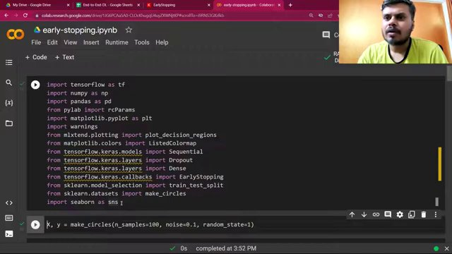

Scatter plot of data points (at 140s)
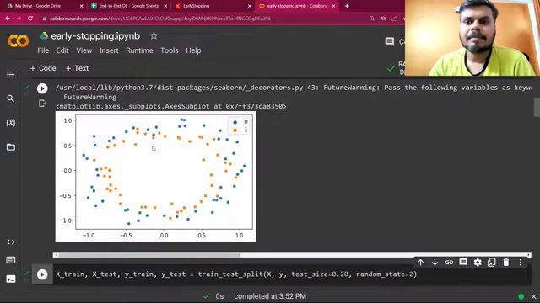

More complete code with model compilation (at 150s)
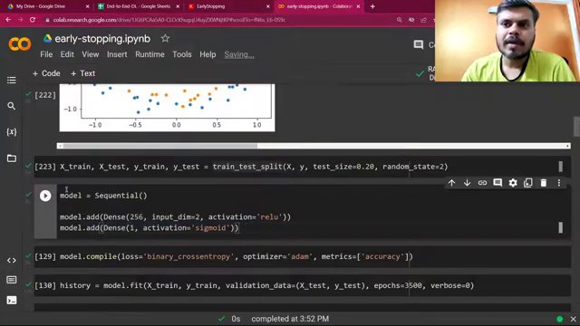

Full code with model training and plotting (at 167s)
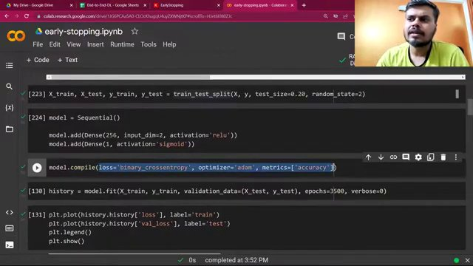

Code snippet with model training and plotting (at 174s)
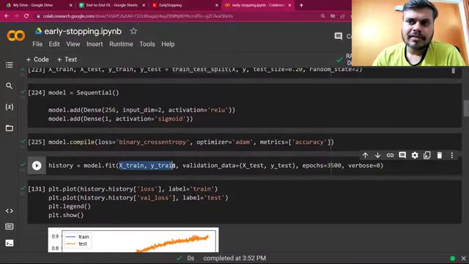

Code snippet with complete plotting and graph (at 213s)
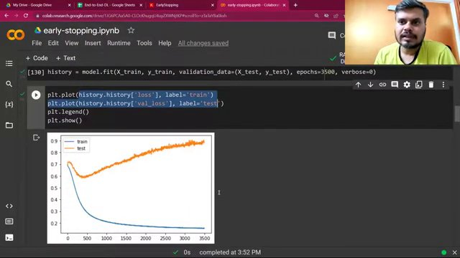

Decision boundary plot with code (at 327s)
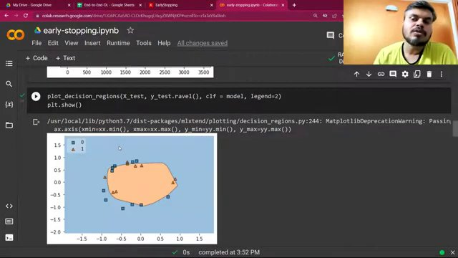

Code snippet with early stopping setup (at 358s)
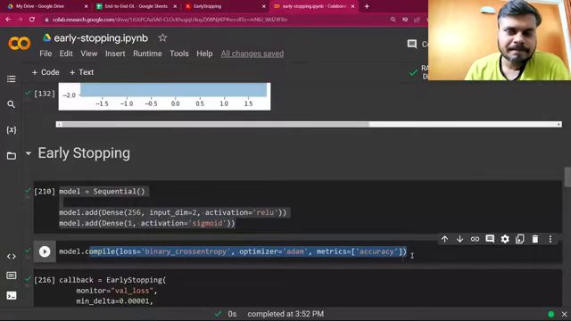

Complete code snippet for early stopping configuration (at 364s)
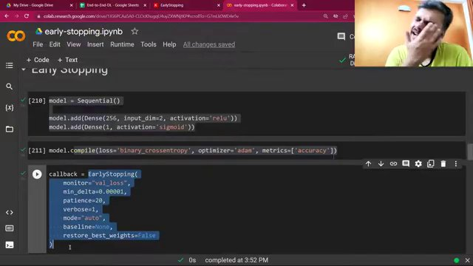

Code snippet for early stopping in a model (at 386s)
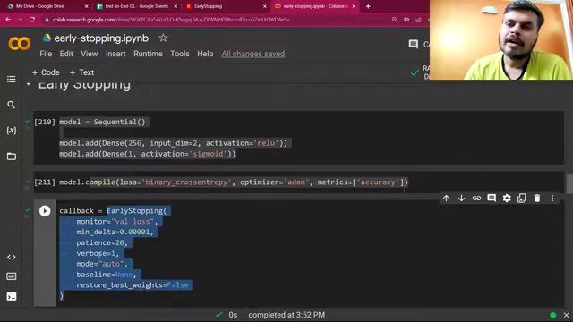

Training output with early stopping (at 412s)
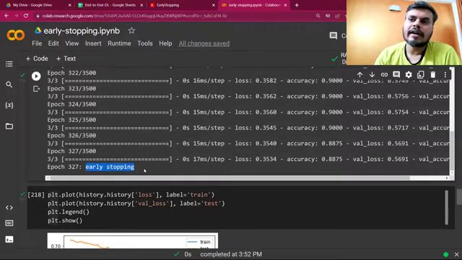

Loss plot for train and test data (at 436s)
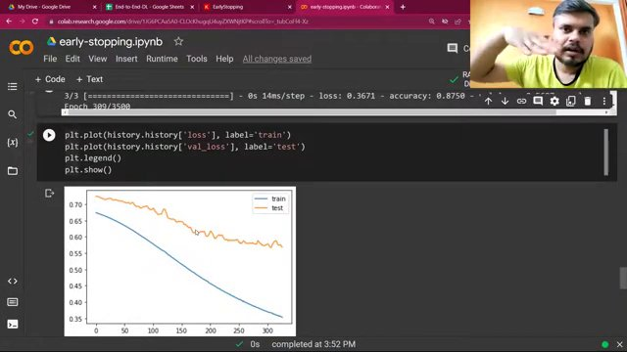

Decision boundary plot (at 456s)
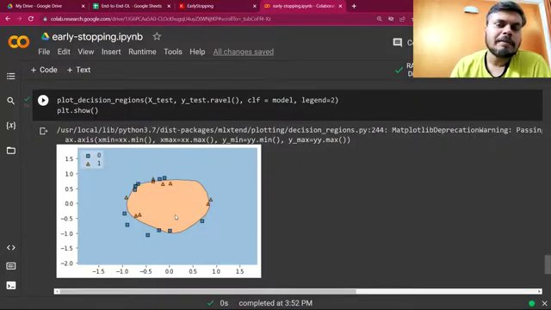

Extended loss plot for train and test data (at 473s)
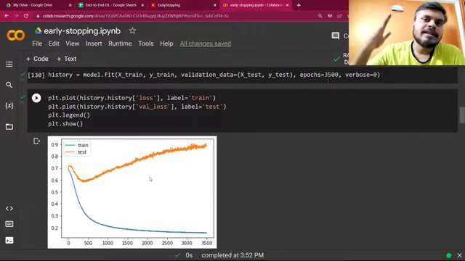

Keras EarlyStopping documentation (at 487s)


Most complete view of Keras API reference with code snippet (at 646s)


Complete code snippet with model training output (at 667s)
